* Have any questions? Call Us
* [+2348023921033](tel:+2348023921033)
* [contact@goldenimpression.net](mailto:contact@goldenimpression.net)

[](https://goldenimpression.net/)

* [**HOME**](https://goldenimpression.net/)
* [**ABOUT US**](https://goldenimpression.net/about-us/)
* [**CONTACT US**](https://goldenimpression.net/contactus-2/)
* **Let's get started in building you**

**An Awesome website!**

LET'S GET YOUR BUSINESS OUT THERE

Website Designers in Lagos Nigeria

GOLDEN IMPRESSION is a team of creative website designers in Lagos Nigeria.  
Our goal is to provide Internet solutions to meet the needs of all consumers – from Corporate to Personal, and everything in between. We offer customized, affordable web design results to each and every client and pride ourselves on the personalized services we provide. Having a website for your organization is no longer an option; it is imperative! We have assisted many organizations to project the right online web presence with the appropriate look and feel.

[[](https://goldenimpression.net/)](https://goldenimpression.net/)

[WEB DESIGN](https://goldenimpression.net/)

[[](https://goldenimpression.net/)](https://goldenimpression.net/)

[DIGITAL MARKETING](https://goldenimpression.net/)

[[](https://goldenimpression.net/)](https://goldenimpression.net/)

[WEBSITE MAINTENANCE SERVICES](https://goldenimpression.net/)

[[](https://goldenimpression.net/)](https://goldenimpression.net/)

[ECOMMERCE SOLUTIONS](https://goldenimpression.net/)

[[](https://goldenimpression.net/)](https://goldenimpression.net/)

[WEB CONSULTING SERVICES](https://goldenimpression.net/)

[[](https://goldenimpression.net/)](https://goldenimpression.net/)

[DOMAIN HOSTING & REGISTRATION](https://goldenimpression.net/)

Some Websites We've Built

[[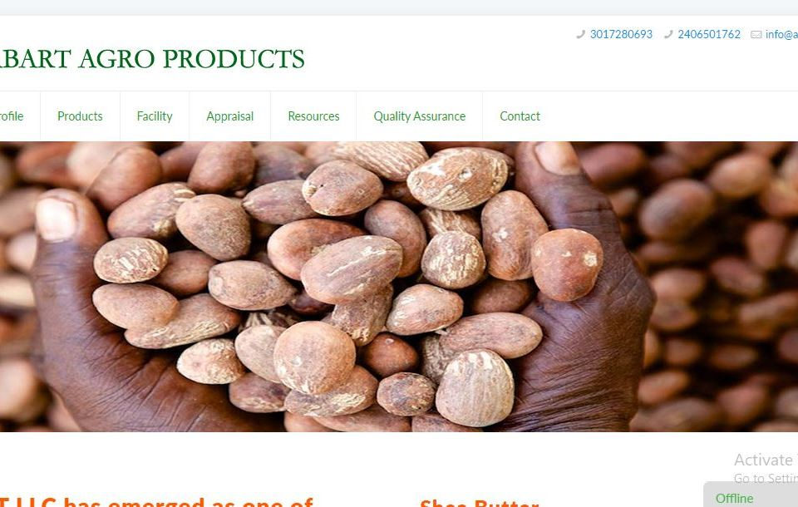](http://www.abartagroproducts.com/)](http://www.abartagroproducts.com/" \t "_blank)

[**Abarto Groups**](http://www.abartagroproducts.com/)

[[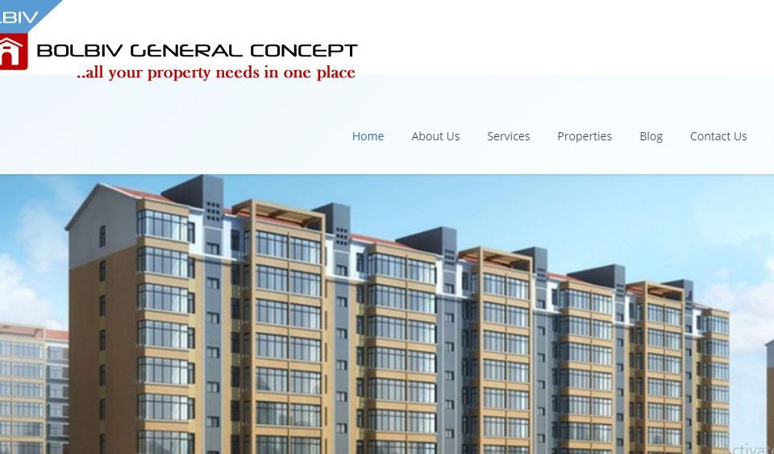](http://www.bolbivproperties.com/)](http://www.bolbivproperties.com/" \t "_blank)

[**Bolbiv Properties**](http://www.bolbivproperties.com/)

[[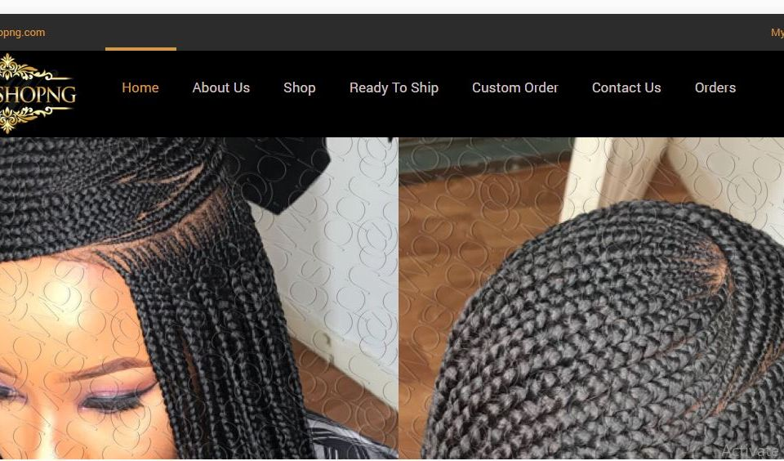](https://www.dwigshopng.com/)](https://www.dwigshopng.com/" \t "_blank)

[**Dwig Shop**](https://www.dwigshopng.com/)

[[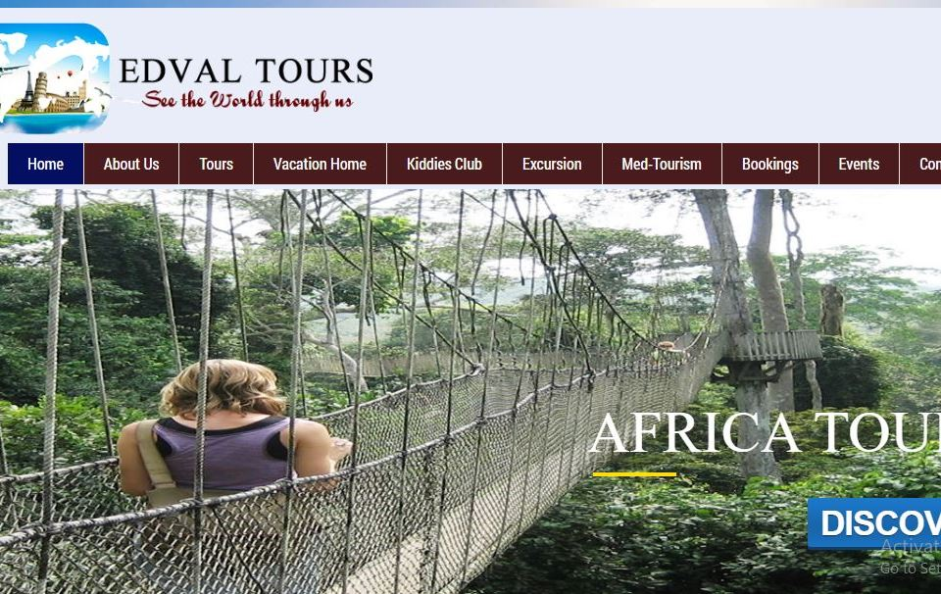](http://www.edvaltours.com/)](http://www.edvaltours.com/" \t "_blank)

[**Edval Tours**](http://www.edvaltours.com/)

[[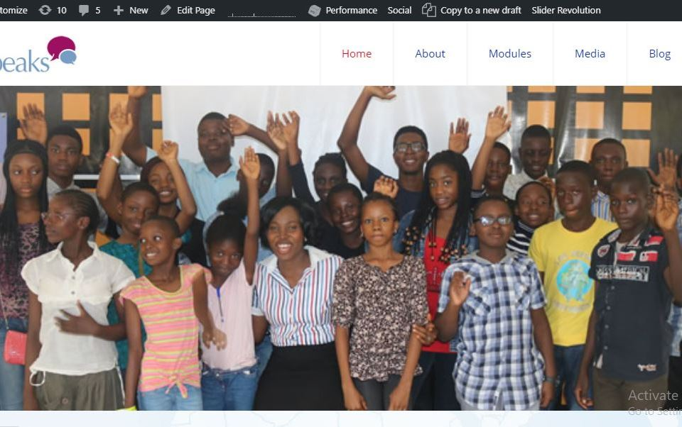](https://www.riospeaks.com/)](https://www.riospeaks.com/)

[**Riospeaks**](https://www.riospeaks.com/)

[[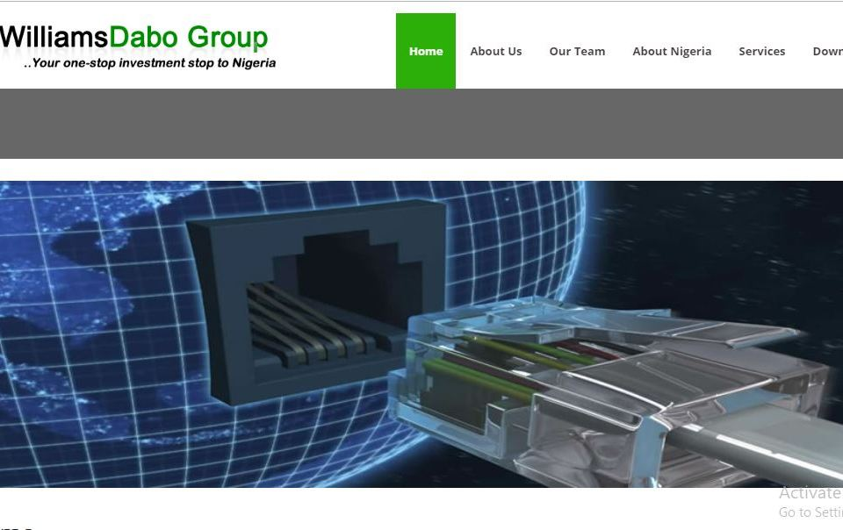](http://www.williamsdabogroup.com/)](http://www.williamsdabogroup.com/)

[**Williams Dabo Group**](http://www.williamsdabogroup.com/)

[[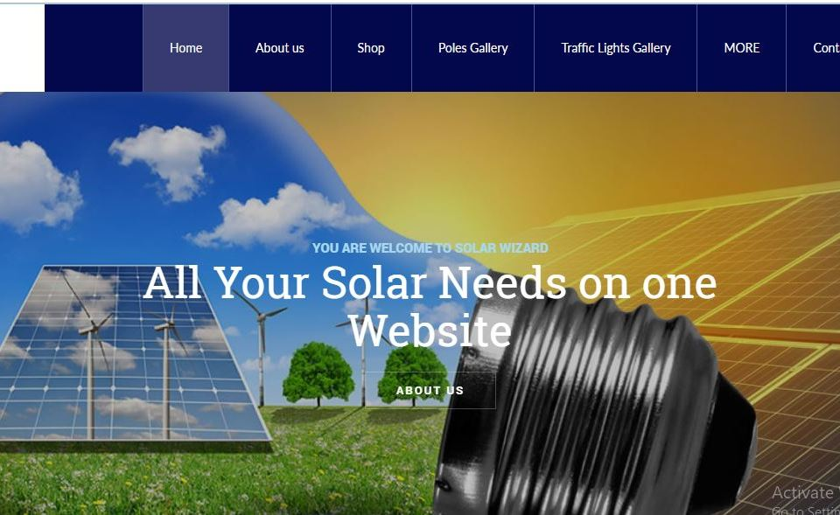](http://www.solarwizardnigeria.com/)](http://www.solarwizardnigeria.com/" \t "_blank)

[**Solar Wizard Nigeria**](http://www.solarwizardnigeria.com/)

[[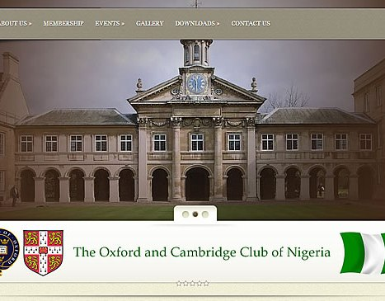](http://oxbridgenigeria.com/)](http://oxbridgenigeria.com/" \t "_blank)

[**Oxbridge & Cambridge Club**](http://oxbridgenigeria.com/)

[[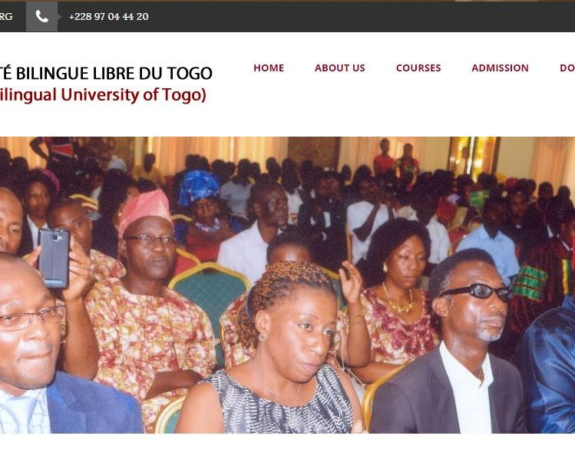](http://www.ubltedu.org/)](http://www.ubltedu.org/" \t "_blank)

[**University of Togo**](http://www.ubltedu.org/)

[[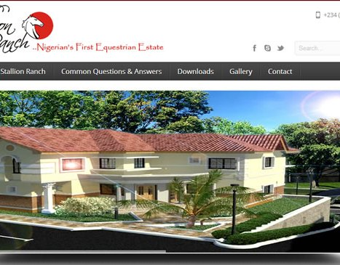](http://stallionranchng.com/)](http://stallionranchng.com/" \t "_blank)

[**Stallion Ranch Properties**](http://stallionranchng.com/)

[[](http://phillyandmools.com/)](http://phillyandmools.com/" \t "_blank)

[**Philly and Mools**](http://phillyandmools.com/)

[[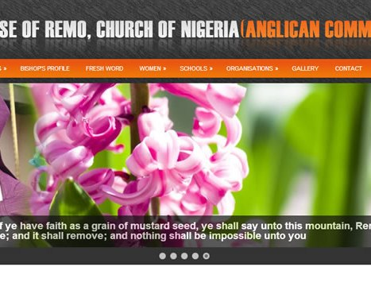](http://remoanglican.org/)](http://remoanglican.org/)

[**Remo Anglican Church**](http://remoanglican.org/)

[[](http://beautyadditions.com/)](http://beautyadditions.com/)

[**Beauty Additions**](http://beautyadditions.com/)

[[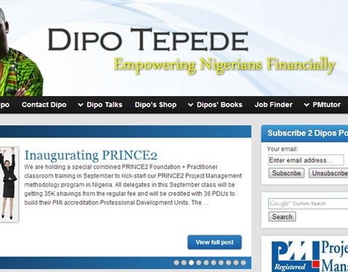](http://dipotepede.org/)](http://dipotepede.org/)

[**Dipo Tepede**](http://dipotepede.org/)

[[](http://laundryonline.com.ng/)](http://laundryonline.com.ng/)

[**Laundry Online**](http://laundryonline.com.ng/)

[[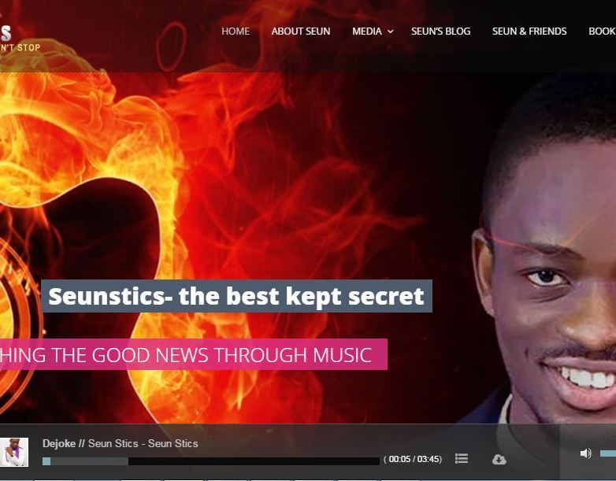](http://seunstics.com/)](http://seunstics.com/)

[**Seun Stics**](http://seunstics.com/)

[[](http://osanielengineers.com/)](http://osanielengineers.com/)

[**Osaniel Enginneers**](http://osanielengineers.com/)

[[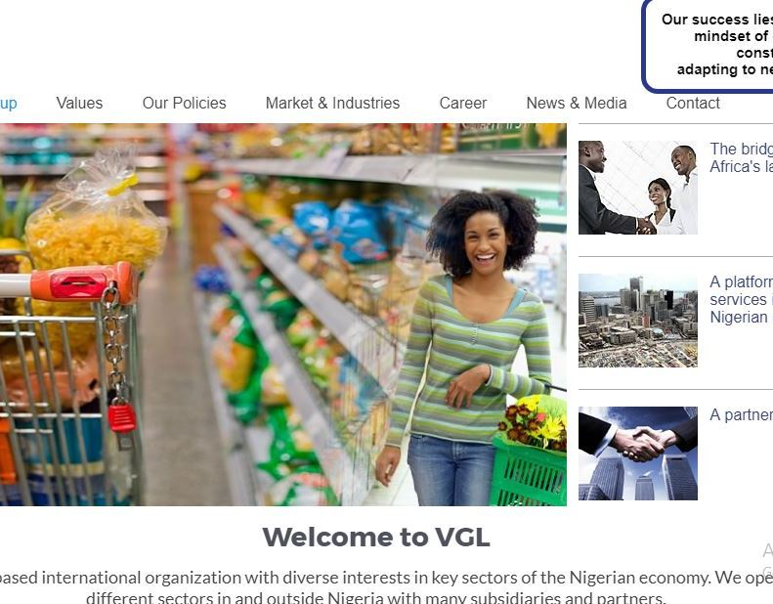](http://vglgroupng.com/)](http://vglgroupng.com/)

[**VGL Group Nigeria**](http://vglgroupng.com/)

[[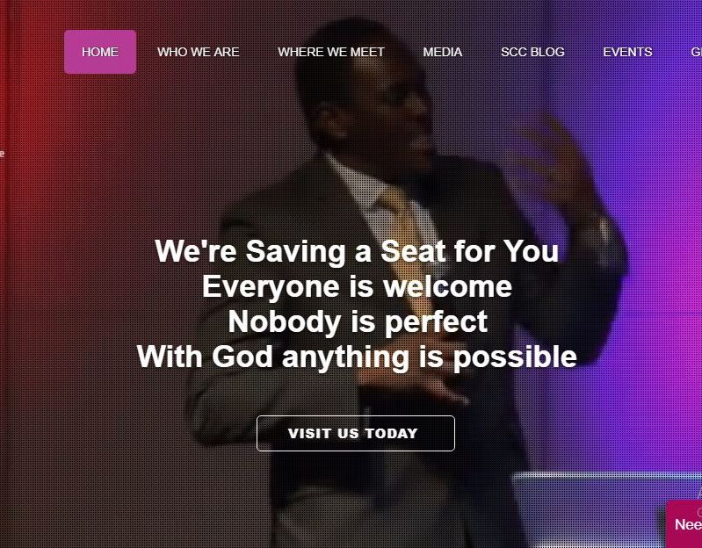](http://scentofchrist.org/)](http://scentofchrist.org/)

[**Scent of Christ Church**](http://scentofchrist.org/)





QUALITY WEB DESIGN

We aim at providing you with the branded customized web solutions offering, high quality web design, web development, e-commerce web development pre- build CMS integration & customization, domain registration, web hosting & much more

CUSTOMER SATISFACTION

Customer satisfaction is our prime motto & we ensure that we provide with 100% customized solutions to our clients. No matter how complex the project is, we are confident that you can count on our company, Golden Impression website designers here in Nigeria to deliver a refine quality within the time frame.

Golden Impression Website Designers

Website Design Company

Lagos, Nigeria

Phone: 08023921033

[08023921033](https://goldenimpression.net/) | [Contact Us](https://goldenimpression.net/contact-us-2/)

Golden Impression websites © 2018 Web design company in Lagos, Nigeria. All Rights Reserved

[[WhatsApp](https://web.whatsapp.com/send?phone=2348023921033&text=Hi%20Golden%20Impression,%20I%20need%20a%20website)WhatsApp Us](https://web.whatsapp.com/send?phone=2348023921033&text=Hi%20Golden%20Impression,%20I%20need%20a%20website" \t "_blank)

* [About](https://heptapixels.com/about/)
* [Work](https://heptapixels.com/work/)
* [Blog](https://heptapixels.com/blog/)
* [Contact](https://heptapixels.com/contact/)

We create amazing websites, outstanding brands and cutting-edge apps.

For close to 7 years, we've designed and built beautiful brands, apps and websites for forward thinking businesses like yours.

[See our work](https://heptapixels.com/work/)

[[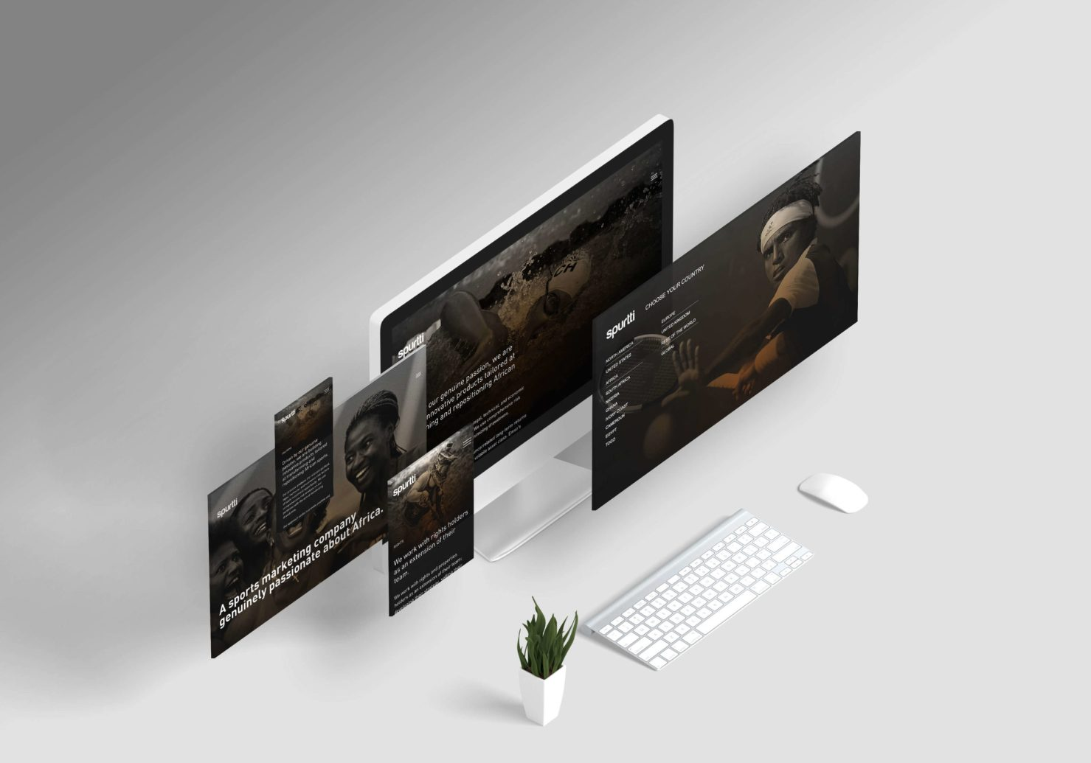](https://heptapixels.com/blog/work/spurtti-website/)](https://heptapixels.com/blog/work/spurtti-website/)

Spurtti Website

We designed a new brand website for Spurtti Global, a sports brand genuinely passionate about Africa

[View project](https://heptapixels.com/blog/work/spurtti-website/)

[[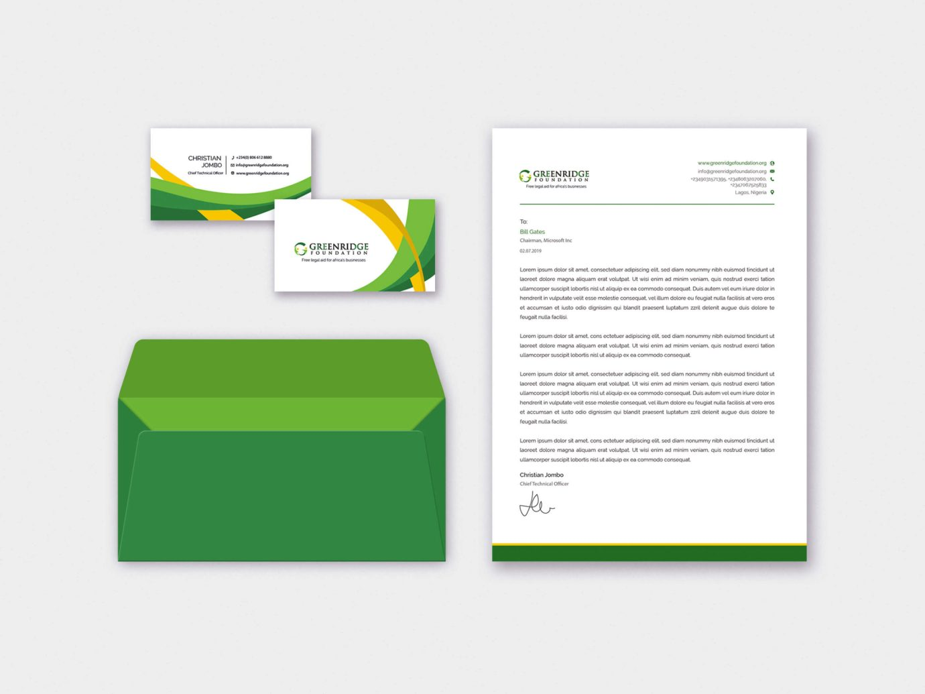](https://heptapixels.com/blog/work/greenridge-branding/)](https://heptapixels.com/blog/work/greenridge-branding/)

Greenridge Branding

We designed an amazing new brand, cool-looking business cards and great letterheads for Greenridge Foundation

[View project](https://heptapixels.com/blog/work/greenridge-branding/)

"Heptapixels blew us away with the exceptional branding and amazing website they produced for our company on such a short notice. We've been able to close promotional deals with two of Europe's most exciting teams because of their invaluable work. They are a partner we will always work with."



James Emeka, CMO

[Spurtti Global](http://www.spurtti.co/)

Latest articles

Our blog is a treasure trove of helpful articles and commentary inspired by what we learn in our day-to-day work.

[See all articles](https://heptapixels.com/blog/)

[[](https://heptapixels.com/blog/how-to-add-read-duration-to-wordpress-posts/)](https://heptapixels.com/blog/how-to-add-read-duration-to-wordpress-posts/" \o "How to add read duration to wordpress posts)

[Wordpress](https://heptapixels.com/blog/category/wordpress/) — 4 mins read

[How to add read duration to wordpress posts](https://heptapixels.com/blog/how-to-add-read-duration-to-wordpress-posts/)

When users visit your blog, they are generally impatient and will most likely leave in a few seconds unless you find a way to convince them to stay.

[No Comments](https://heptapixels.com/blog/how-to-add-read-duration-to-wordpress-posts/#comments)

[[](https://heptapixels.com/blog/you-still-need-a-website-and-heres-why/)](https://heptapixels.com/blog/you-still-need-a-website-and-heres-why/" \o "You still need a website and here’s why)

[Uncategorized](https://heptapixels.com/blog/category/uncategorized/) — 4 mins read

[You still need a website and here’s why](https://heptapixels.com/blog/you-still-need-a-website-and-heres-why/)

With the advent of several social media platforms and social marketing, it is still worth it to own a website? Of what use is a website anyway?

[No Comments](https://heptapixels.com/blog/you-still-need-a-website-and-heres-why/#comments)

Need help with your brand, website or app? We’d love to work with you!

We've worked with lots of businesses and organisations to design, build and launch amazing products with forward-thinking design, data-driven insight, and improved user experiences.

[Let's get started](https://heptapixels.com/get-started/)

Heptapixels © 2020

A Nigeria based digital agency building amazing websites and cutting-edge apps that drive results for various organisations 🤩

[Privacy Policy](https://heptapixels.com/privacy-policy/)

Join Our Community

Let's deliver exclusive content to improve yourself and grow your business, straight to your inbox.  
[Sign up today](https://heptapixels.com/newsletter/)

Get Social

[Facebook](https://facebook.com/heptapixels/)  
[Instagram](https://instagram.com/heptapixels/)  
[Twitter](https://twitter.com/heptapixels/)

Contact Us

[hello@heptapixels.com](mailto:hello@heptapixels.com)  
[+234-806-612-8880](tel:+234-806-612-8880)

:)